K-Illustration Fair Seoul 2026

1. Participant
*Please, read carefully the exhibition regulations before filling out the application form.
Classification | □ Individual Artist □ Company / Organization / Association
Name of Sign
Name of Artist | In case of Individual artist |  |  | Artist’s Real Name | In case of Individual artist
Address | (Zip code)
Contact No. | (Country Code) |  |  | Fax | (Country Code)
Website/SNS |  |  |  | E-mail
Representative |  |  | Person in Charge |  | Cell Phone
Exhibition Items (Please check in the box)
Individual Artist | □ Illustration □ Graphic Design □ Character Design □ Painting □ Live Painting □ Picture book  □ Indie publisher □ Webtoon □ Cartoon □ Game □ Animation □ Caricature □ Calligraphy  □ Typography □ Others
Company / Organization / Association | □ Government Agency □ Arts Materials □ Production & circulation of Art goods □ Character Business  □ Design Studio □ Devices □ Publication & Distribution □ Production & distribution of Papers □ Agency  □ Artist Platform □ Related Website / Application □ Education □ Community □ Gallery  □ Bookstore □ Ohters
Singularity of Items |  | ※ If you have any significant when displaying, please fill our this box

2. Application for Exhibition Space
Booth Type | Dimensions  (W X D X H) | Unit Price | 신청 부스 | Sub-Total
Wooden A | 2.0m(1.0m) X 2.0m(1.0m) X 2.4m | USD 900 | Booth(s) | USD
Wooden B | 2.0m X 2.0m(1.0m) X 2.4m | USD 1,100 | Booth(s) | USD
Wooden C | 3.0m X 2.0m X 2.4m | USD 1,600 | Booth(s) | USD
Standard Shell A | 2.0m X 2.0m X 2.5m | USD 800 | Booth(s) | USD
Standard Shell B | 3.0m X 2.0m X 2.5m | USD 1,200 | Booth(s) | USD
Raw Space | 3.0m X 2.0m (* more than 2 booths) | USD 1,100 | Booth(s) | USD
Corner Booth (exposed to 2 hallways) |  | USD 50 | Booth(s) | USD
※ Raw Space: Organizer provides only exhibition space, should be applied more than 2-booth.
※ If you want to be placed on corner, there would be additional cost(USD 50) after discounting total booth cost.
※ Wooden A & Standard Shell A booth is not opened to Companies.
※ The booth information above is subject to change depending on the circumstances of host.
※ Design of Booth
Wooden A | Wooden B | Wooden C
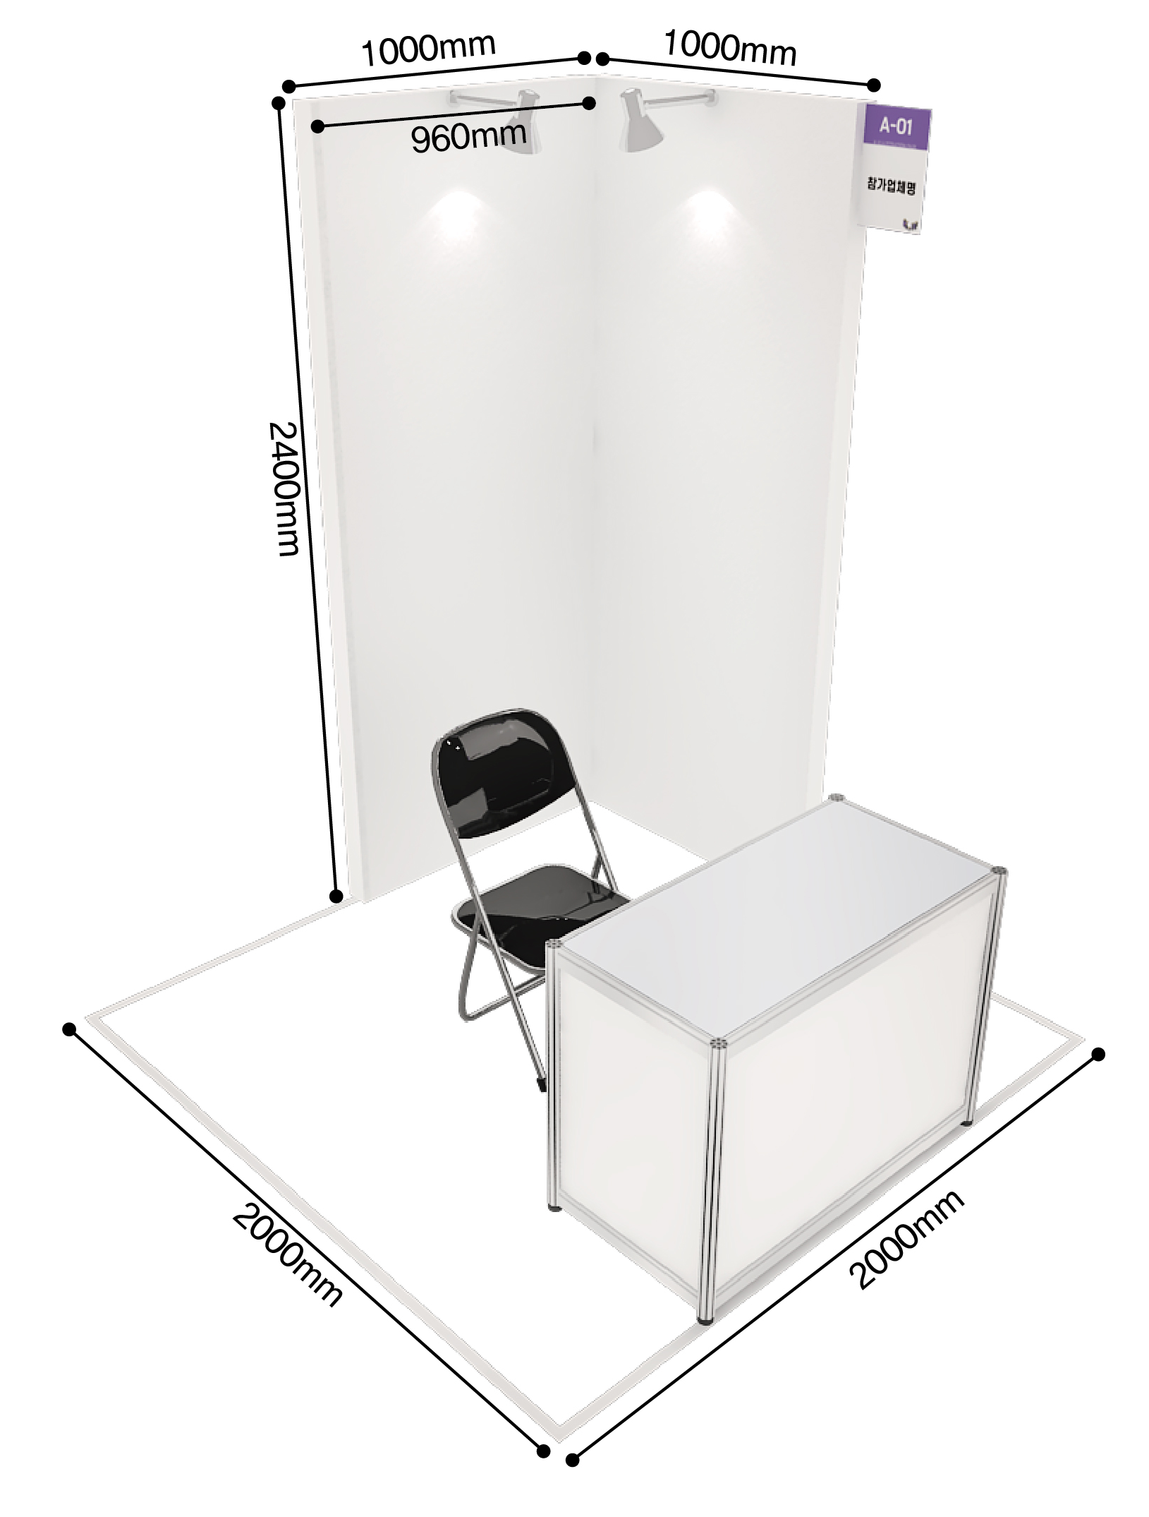  Nameplate, 2 lighting, 1 electrical outlet (1KW; 220V), 1 information desk & chair | 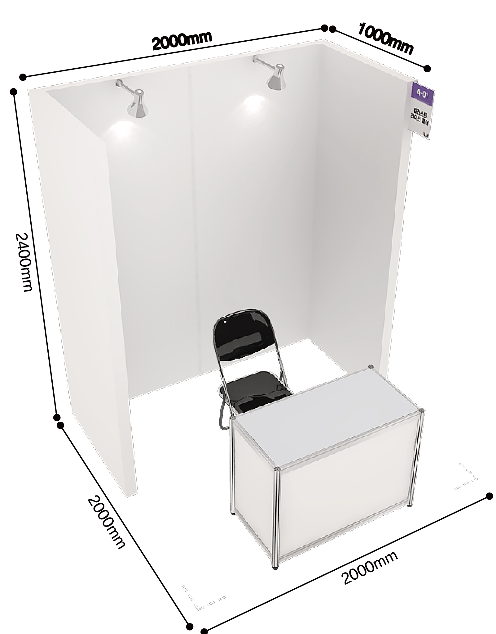  Nameplate, 2 lighting, 1 electrical outlet (1KW; 220V), 1 information desk & chair | 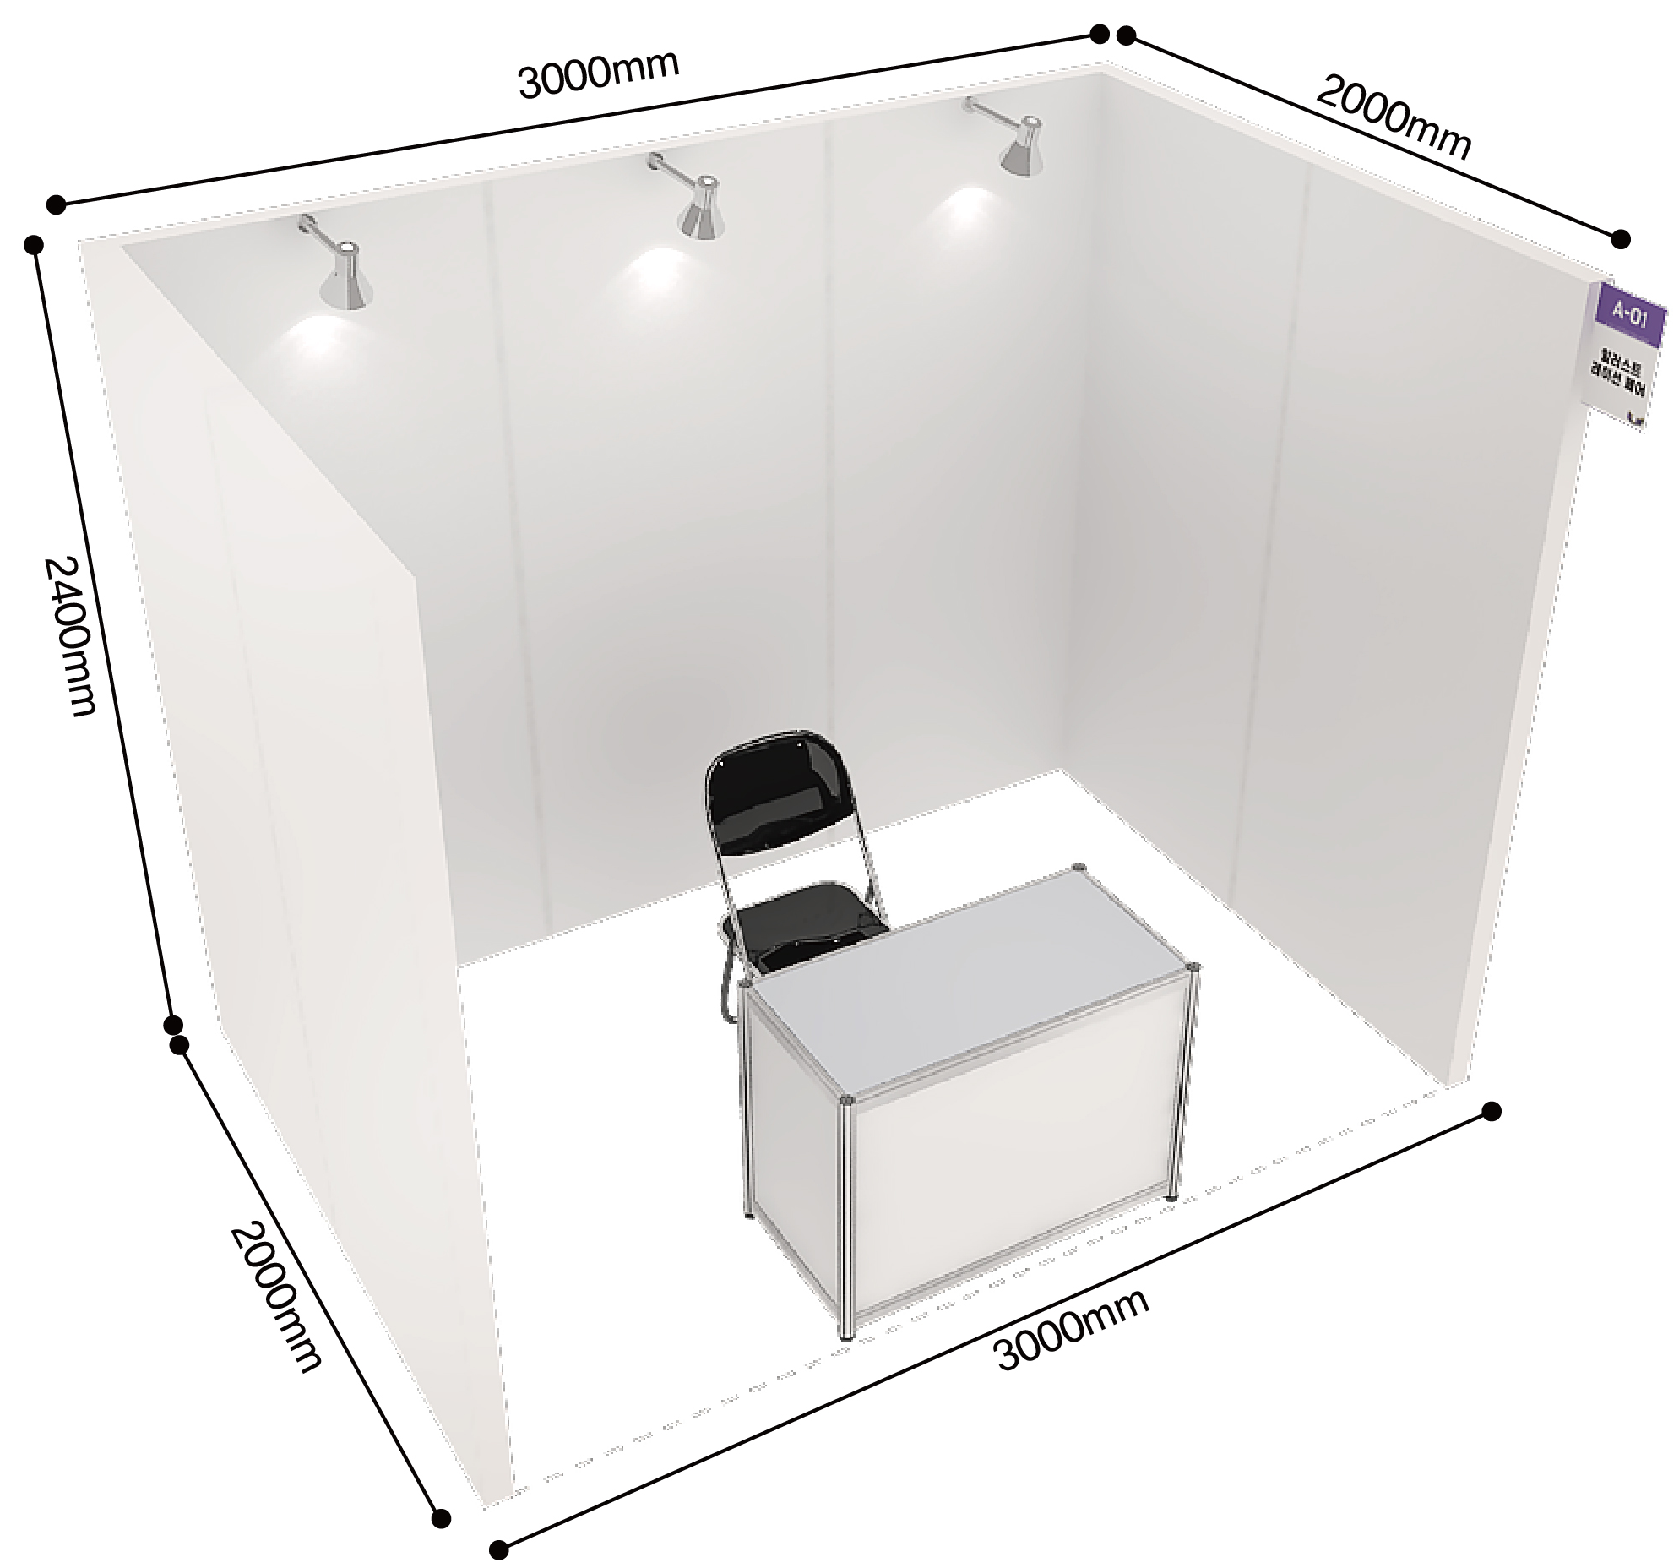  Nameplate, 3 lighting, 1 electrical outlet (1KW; 220V), 1 information desk & chair
Standard Shell A | Standard Shell B | Raw Space
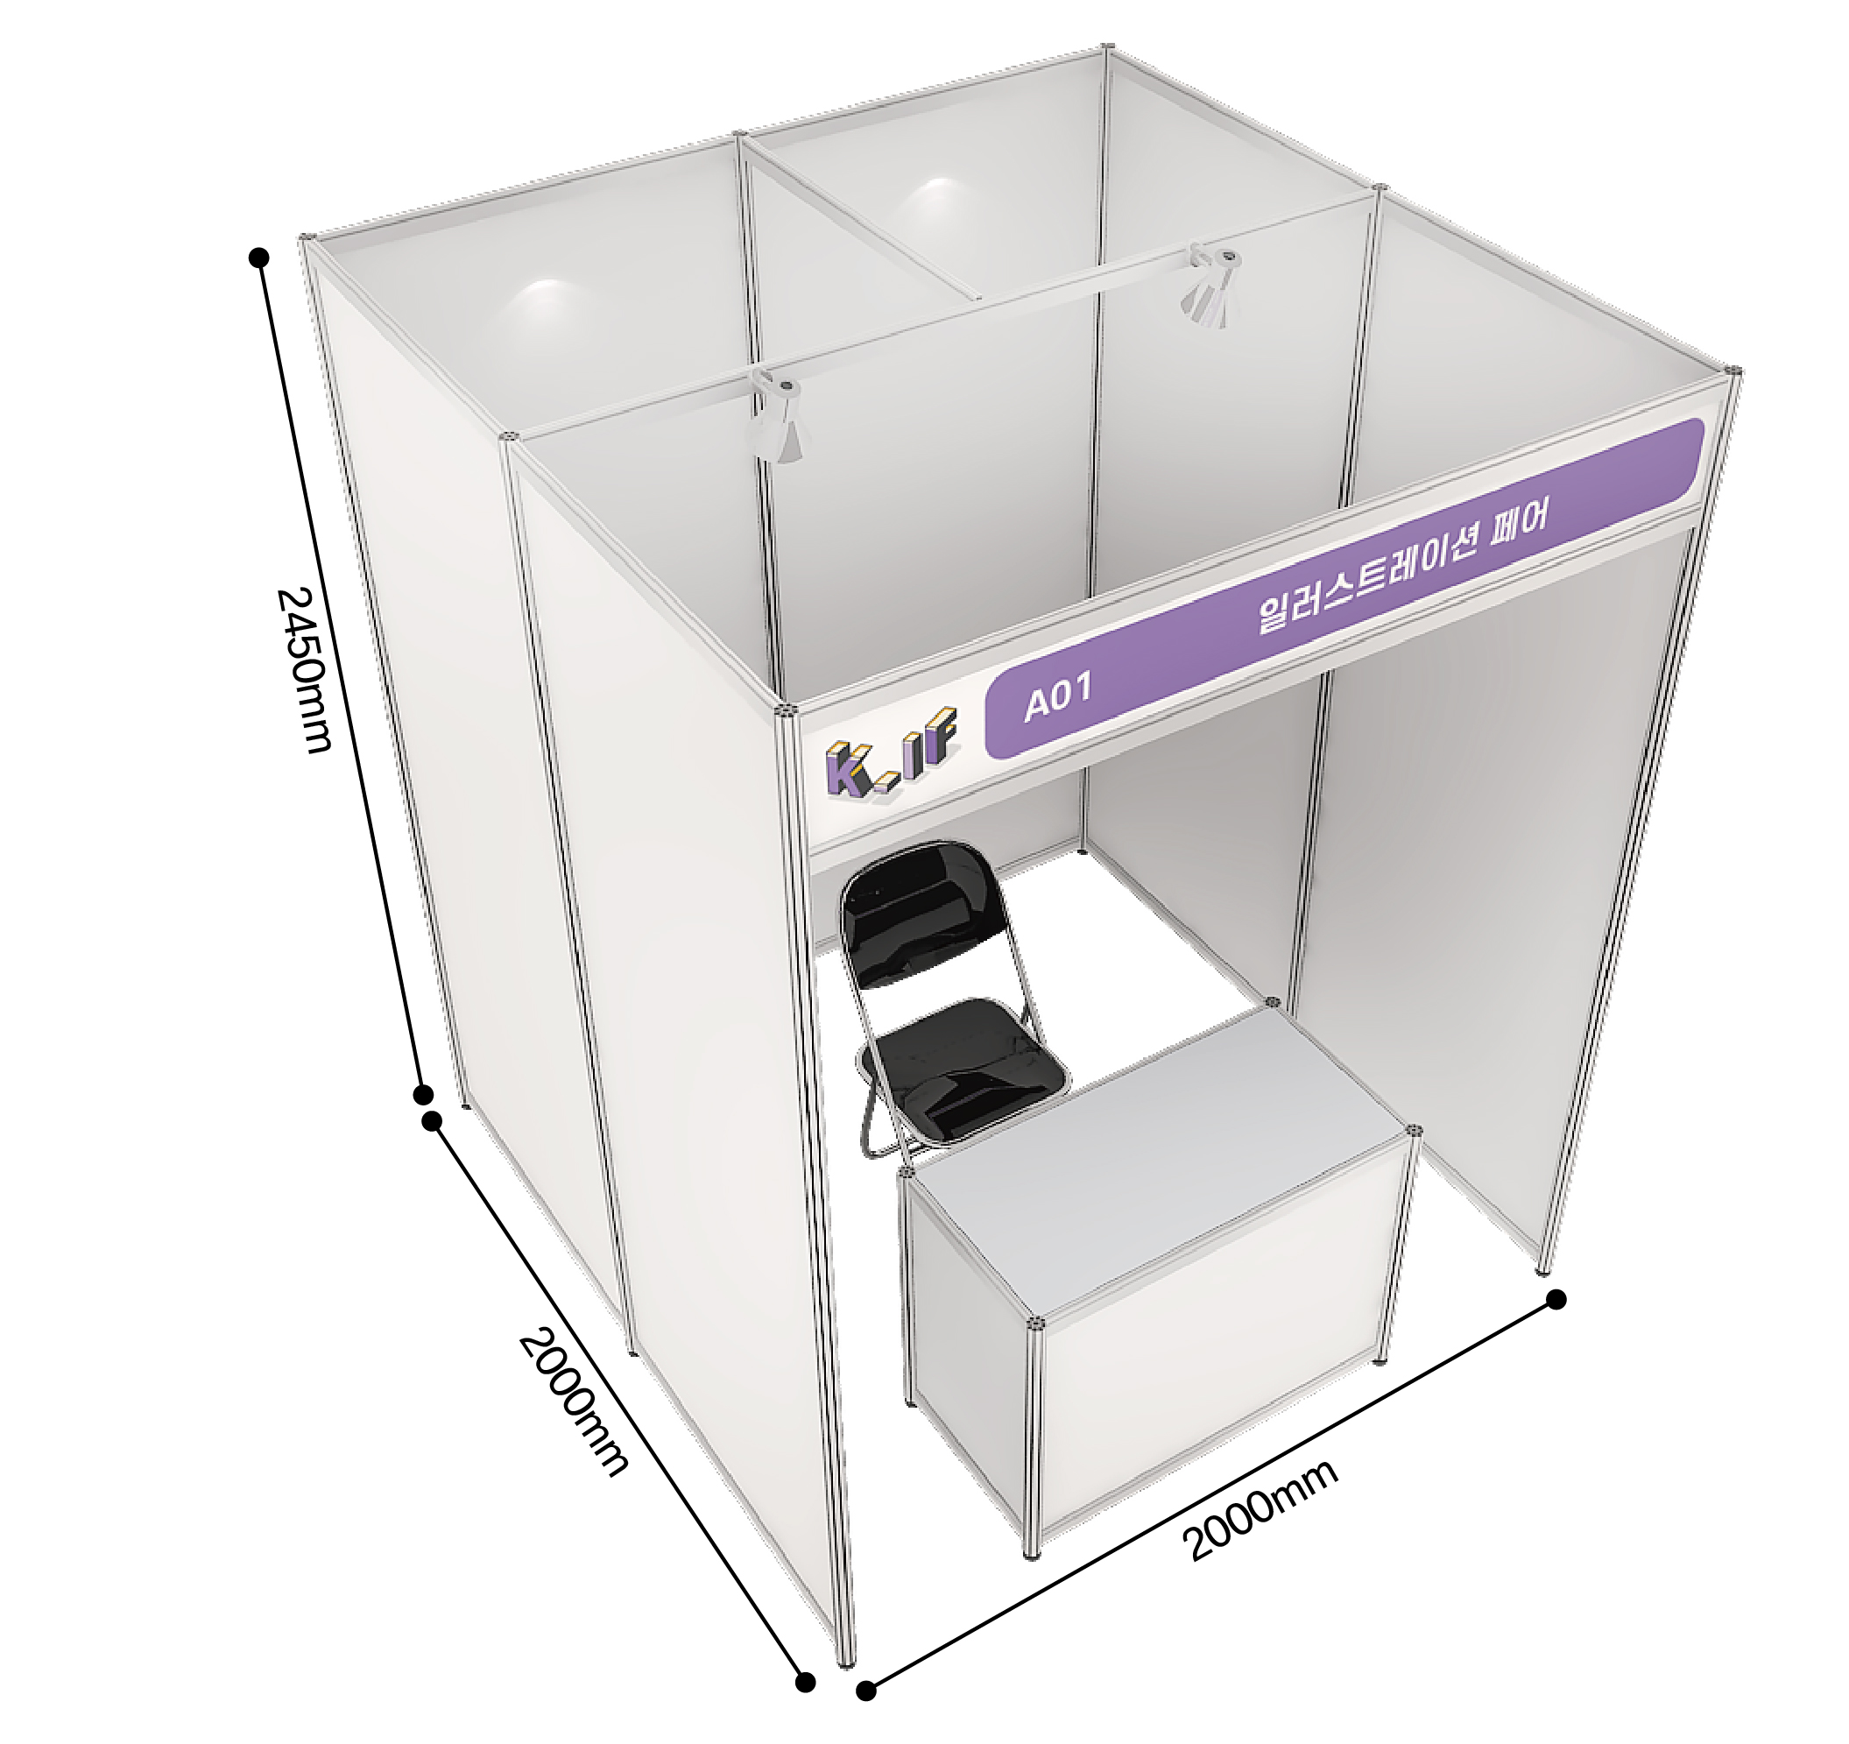  Nameplate, 2 lighting, 1 electrical outlet (1KW; 220V), 1 information desk & chair | 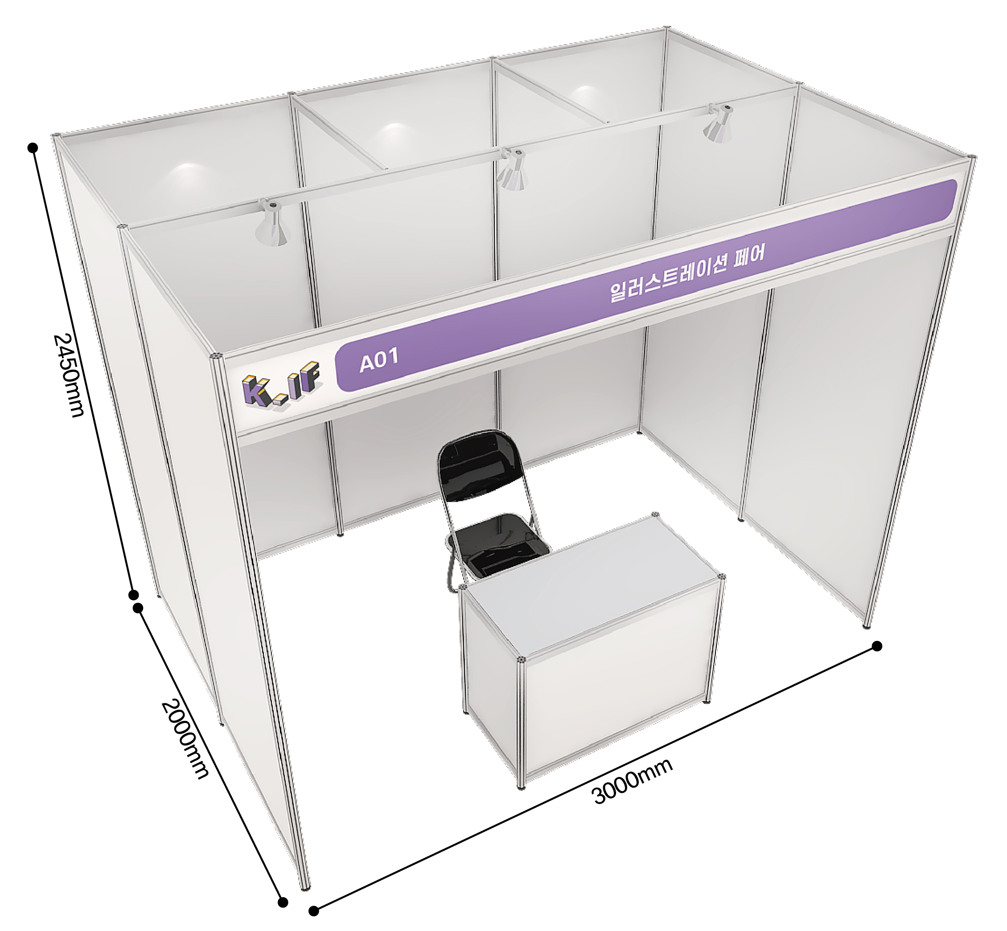  Nameplate, 2 lighting, 1 electrical outlet (1KW; 220V), 1 information desk & chair | 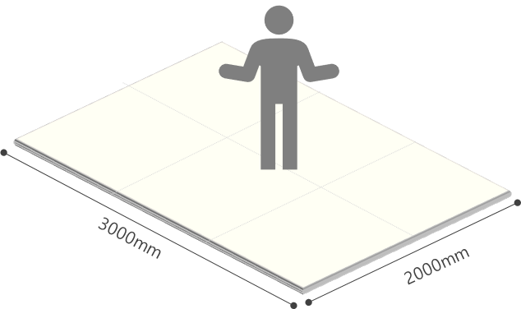  Exhibition space only (※ more than 2 booth)

■ Discount Program (Please check in the box)

Sponsor Support Discount Program | □ Selected by the Secretariat after submitting portfolio(30%)
Additional Discount | □ Previous Participants(5%)

※ ‘Sponsor Support Discount Program’ is not applicable to Companies.
※ Corner Booth cost cannot be discounted.

■ Submitting Portfolio

Please upload more than 3 images of your artworks on your social media or website and fill out the link below.
※ When you upload your artworks on your social media, please write the hashtag ‘#K일러스트레이션페어’ and make the post public.
Portfolio Link
※ Make sure that link start ‘http~’
※ Up to 3 links
Years of Experience * | □ Yes, I have experiences ( Years ) □ No, I don’t have experiences
Career history
※ If you don’t have, please leave it blank.
※ It should be limited to 3000 words.

I, hereby, confirm that I will follow the rules & regulations of ‘K-Illustration Fair Seoul 2026’ and that I have enclosed a payment (50% of the participation fee) and a copy of the payment remittance.

/ /
DD/MM/YY |  | Name of Applicant (Representative) |  | (Signature)

■ Please, make the deposit to;
• Bank: Shinhan Bank • Account No.: 180-006-181212 • Beneficiary: Korea Int'l Exhibition co., LTD
• Swift Code: SHBKKRSE • Address: 57, yeouinaru-ro, yeongdeungpo-gu, Seoul (Yeouido-dong)
■ How to Apply; Tel: 82-2-761-2512 | Fax: 82-2-761-2517 | Email: info@k-illustrationfair.com
Address: No. 1116, (Yeouido-dong), 33, Gukjegeumyung-ro 6-gil, Yeongdeungpo-gu, Seoul
※ Online Application (Korean) : www.k-illustrationfair.com

The Rules & Regulations of K-Illustration Fair Seoul 2026

Article 1 Definition
1. "Exhibition" refers to ‘K-Illustration Fair Seoul 2026’.
2. "Organizer" refers to ‘Korea Exhibition Organizing & Management Business’
3. "Exhibitor" refers to individual(artist), company, organization or group applied for the participation in this exhibition.

Article 2 Exhibition application and agreement
1. The one who wish to participate in the exhibition shall fill the application form, receive approval from the organizer and pay 50% of the total participation fee by bank transfer within 7 days.
2. After submitting the application form, if the organizer refuses to approve for harmonious constitution and operation of the exhibition, the agreement will not be effective.
3. Participation fee is;
Booth Type | Unit Price | Booth Type | Unit Price
Wooden A | USD 900 | Standard A | USD 800
Wooden B | USD 1,100 | Standard B | USD 1,200
Wooden C | USD 1,600 | Raw space  (Space Only) | USD 1,100
※ Corner booth price is not included in the unit price. (USD 50)
4. Technical support and standard package construction will be provided by the organizer upon the request of the exhibitor. In case of any alternation in technical support request, the exhibitor shall inform the organizer in prompt manner. Any disadvantage occurred by the non-inform is subject to the exhibitor’s responsibility.
5. The exhibitor shall display only the items specified in the application form, and if the signboards, business names, items, etc. differ from the details of the application on the day of the exhibition, the organizer may remove the relevant business from the site.
6. Method of Payment
· Bank: Shinhan Bank
· Account No.: 180-006-181212
· Beneficiary: Mun, Young Su
· Swift Code: SHBKKRSE

Article 3 Copyright Protection
1. Exhibitors cannot participate in this fair with artworks or goods infringing intellectual property rights.
2. If the exhibitors display goods using derivative works, it is required to accept consent form original artist and submit the documents that can prove it has been accepted to the Organizer.
3. During the exhibition period, if there happened problems that exhibitors infringe copyright of other intellectual property rights or display/sell artworks or goods not accepted from original artist’s consent, exhibitors should stop displaying/selling it and shall be liable for any damage caused. Also, Organizer can demand compensation for it.
4. If Exhibitor participate in this fair with artworks or goods infringing intellectual property rights or derivative works, he/she cannot participate in this fair for 5 years.

Article 4 Assignment of Exhibition Booth
1. Organizer has all rights to the booth assignment and Exhibitor may not object to the decision made. According to application and payment order, booth will be assigned considering country, item, size, exhibition results and other reasonable matters.
2. The organizer may change the allocated booth location in case the organizer acknowledges the necessity considering spacing harmony, viewing efficiency and exhibition effectiveness. Such change is under discretion of the organizer, and the exhibitor shall not object on the decision.

Article 5 Exhibition Management
1. Exhibitor shall display the items listed in the application and have someone to take care of the booth at all times.
2. If the Exhibitor displays items not listed in the application or if displayed item does not fit the nature of the exhibition or conducts direct sales without approval from the Organizer, Organizer can request to stop, withdrawal or dismantle. This case, participation fee is not refundable, and Exhibitor may not ask for compensation.
3. Organizer may prohibit certain people from the exhibition, if necessary.
4. Exhibitor cannot use other area for the exhibit without prior approval from Organizer.
5. Exhibitor cannot use speaker or amplifier without prior approval Organizer and sales, or loud activities are strictly prohibited.
6. For any damages that cannot be returned into original state, such as painting the floor/ceiling/wall, Exhibitor is liable for any reasonable compensation requested by Organizer regarding the restoration.

Article 6 Payment
1. Exhibitor shall make a payment of the total participation fee within 7days after submitting application.
2. In the event of Exhibitor not making a payment within the designated deadline, organizer may cancel the contract and the Exhibitor cannot ask for refund. The matter will be resolved according to Article 7 of this Rules and Regulation.

Article 7 Termination of the Agreement (Exhibition Cancellation) and Penalty
1. The Exhibitor cannot assign the contract, sub-let or part with his site or stand or any portion of it without prior written consent from the Organizer. If the Exhibitor breaches this term, exhibition can be cancelled, and the fee will not be subject to refund.
2. If the Exhibitor does not pay the participation fee within the designated period, 14days notice will be given to him/her to make the payment and still if the payment is not made, Organizer has the right to cancel the exhibition contract. In this case, Exhibitor is not entitled to refund.
3. In case the exhibitor cancels or refuses the whole or partial space, which is already registered due to own reason, the exhibitor shall inform the organizer in document and pay the penalty that is settled below within 14 days. Penalty is deducted from the paid participation fee, if not sufficient, the exhibitor shall pay the addition, and if surplus, the balance will be returned.
* Cancellation Penalty
- Prior to May 3rd(Sat.) 2025 : 20% of participation fee
- From May 4th(Sun.) 2025 to August 1st(Fri.) 2025 : 50% of participation fee
- From August 2nd(Sat.) 2025 to January 13th(Tue.) 2026 : 80% of participation fee
- After January 14th(Wed.) 2026 : 100% of participation fee

Article 8 Display of items
1. Exhibitor shall complete installment, entrance and display of the item within the designated date. In case of items not being displayed until 11 am, Jan 29th(Thurs.), 2026, which is the opening hour of the exhibition, Organizer has the right to temporarily cancel that exhibition and ask for compensation.
2. Exhibitor can use their own space given by Organizer for the display of their items only from opening time to 8 p.m. on designated date. If additional working hour is required, additional work application shall be submitted and extra charge shall be made.

Article 9 Restoration
1. Exhibitor shall observe the opening and closing time, and all disadvantages arising from violation of this rule shall be the responsibility of the participant.
2. After the exhibition (Feb 1st(Sun.), 2026, 6pm-), Exhibitor shall restore booth space to the original state as fast as it possible. Exhibitor is liable for any expenses/losses, including additional charge caused by delay, arising to the Organizer from a delay of dismantling.

Article 10 Security and Safety
1. Organizer shall take proper action (COEX’s exhibition regulation) to secure safety for the Exhibitor and visitors.
2. Exhibitor is fully liable for any damages or loss occurred during the exhibition preparation period, exhibition period and dismantling period.
3. If Exhibitor intently caused fire, damage, loss or other accidents causing loss to Organizer or any 3rd party, Exhibitor is fully liable for the cause and insurance regarding all materials and items.

Article 11 Fire Safety
1. All materials and items must be fire resistant according to the safety regulations.
2. Organizer may ask for modification regarding fire prevention to the Exhibitor if necessary.

Article 12 Amendment
1. The Organizer reserves the rights to modify at any time the provisions of the present Rules & Regulation; the Exhibitors shall comply with the modification.
2. The Exhibitors must comply with the regulations of COEX.

Article 13 Disputes
In any disputes that may arise concerning interpretation of the present Rules & Regulations, the Exhibitor agree to the competence of the Commercial Arbitration Rules of the Korean Commercial Arbitration Board and shall not bring a law-suit against the ruling.

